
Prayer Ideas 1

- Use a dice
 | Personal response | Emotions | People in school
1 | thank you
2 | please
3 | sorry
4 | help
5 | remember
6 | forgive

- Use a coloured cube – each face to represent an emotion – happy / sad / afraid / lonely / excited / pleased

- Prayer/hope tree – children write prayers/hopes on paper leaves

- Prayer/worry box – prayers could be used in collective worship

- Children writing prayers – individual/class/whole school

- ‘Directional’ prayers – north, south, east, west
  - School community
  - Local community
  - Regional/uk community

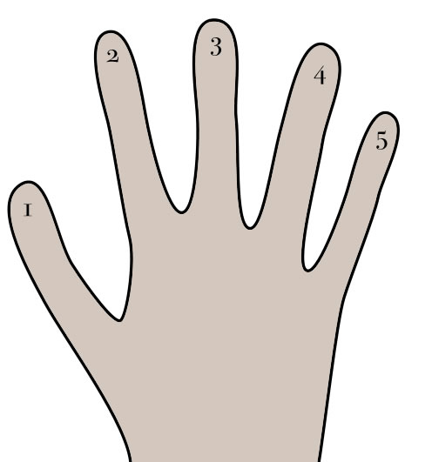
- Globe – global community

- Using hands – good things / strength or health / people in need / direction / people you love or care about

- Thank you / celebration aeroplane prayers

- Famous prayers
  - The Lords prayer
  - Prayer of St Francis

- Prayer paper chains

- Pebble prayers / pebble pools

- School prayer / class prayer / lunch-time prayer

- Flame prayers (flame shapes/hands)

