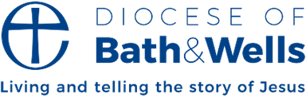

Manna Mailing June 2026
Celebrating our volunteers
Where would we be without our volunteers? The first week in June is National Volunteers Week, which is described as ‘a UK-wide celebration recognising the contribution of volunteers’. There may be a ‘week’ or a ‘day’ to celebrate a whole host of different things, but one in which we can say a big ‘thank you’ to all those that enable the Church of England to be all that it is in our Diocese of Bath and Wells is one not to ignore.
So, if you are one of those volunteers, thank you!
As well as the many people in our churches who provide such valuable support, we also have a host of volunteers that help our diocese function, serving on a range of committees and groups.
The Finance Group is one of those groups that ensures the diocese meets its legal obligations and enables it to function effectively. Long serving member Mal Lee, says, “Being part of the Finance Group is a great privilege and is really interesting.
“The Group is part of the governance framework by which our diocese is directed. Bath and Wells is very much a people organisation, and the Finance Group recognises the importance of the work undertaken by individuals and benefices that form such an essential part of our diocese.”
There are at least 21 formal diocesan committees, not to mention more informal groups supporting different areas of activity, such as our Year of Prayer and lay ministries development. Some volunteers are members of clergy, but the majority are lay. If you want to know more about our different committees and consider whether you could join one of them, go to our diocesan website: bathandwells.org.uk/how-our-diocese-works.

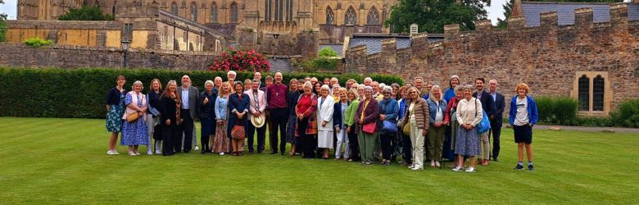
Over the last few years Bishop Michael has been welcoming parish volunteers performing different roles join him for Evensong at Wells Cathedral and an informal reception at the Palace.
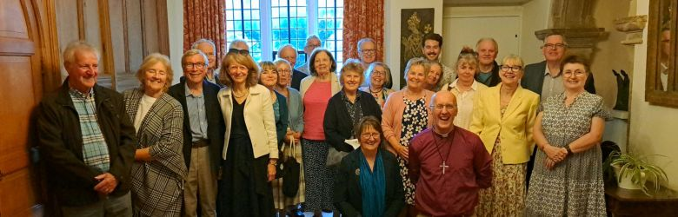

News in brief
One Body, One Tree, One Life
A unique exhibition of candid photographs of church members from St Andrew’s Church, Cheddar was created by Eleanor Motion, a Bath and Wells Young Adult Representative on General Synod. Eleanor, who is a photography student, designed, created and took all the photos for the exhibition. Installed in St Nectan’s Chapel inside the church it sought to reimagine the cross as the root of a four-foot Somerset cider apple tree. Eleanor said, “The real heart of the exhibition is the people who helped me build it.”
Listen, learn and act
The first of a series of events aimed at looking at and discussing racial justice and the role of faith in troubled times took place in Weston-super-Mare. Led by Anira Khokhar Bath and Wells Racial Justice Adviser and Revd Narinder Tegally, it was organised with Racial Equality North Somerset (RENS) to explore how faith communities can respond to racism and division in practical and hopeful ways. Anira encouraged everyone to start their racial justice journey in the simplest way, by having an open and honest conversation. Addressing those gathered Revd Narinder Tegally, Bath and Wells Interfaith Adviser said, "Racism is not an abstract issue for the Church of England; it is a lived reality that touches parish life, leadership, history, and witness.”
Environmental support from local students
A team of students from Bath University is using 3D laser scanning and community engagement to help decarbonise St Stephen’s Church, Bath. Students are working with the team at St Stephens on an innovative sustainability collaboration to cut carbon emissions and explore sustainable options to support new and financially viable community uses for the building.
Using laser scanning and 3D modelling, students are identifying priority repairs and practical ways to save energy, including improvements to heating, lighting and insulation, as well as the potential use of renewable technologies. Alongside technical work, the team is working with residents and community groups to understand how the church could accommodate a wider range of activities.

Transforming our communities through the love of Christ
By Fiona Gibson, Bishop of Taunton
In the early days of the Ukraine war, the Diocese of Hereford, where I was then serving, was approached by Herefordshire Council. They had been so impressed by the work of church members during the pandemic, who stepped up to support their communities in practical ways, that they asked if the diocese could take on organising homes for Ukrainians fleeing the war. Yes, of course, we said. And so began an ongoing partnership, where hundreds of Ukrainian guests have found homes in the Welsh Marches, and hundreds of tonnes of aid has gone across to Ukraine.
That’s just what we do as the church, isn’t it? We see a need in our communities and, motivated by Christ’s love and teaching, we try to meet it. And we do it out of love, not seeking any reward. We are volunteers.
The word ‘volunteer’ comes from words meaning, ‘of a person’s free will.’ Volunteers serve willingly. Freely. Out of love. So many in across our diocese serve our communities willingly, freely, out of love. We are deeply grateful. There are Foodbanks, lunch clubs, debt counselling services, mental health first aiders, bereavement cafes, after-school clubs, and youth drop-ins. That barely scratches the surface. All of this is done in the name of Jesus Christ, the one who came and gave himself for us willingly; freely; out of love. And it’s transformational.
One of the areas of our common diocesan life which I’ll be involved with is our work around Transforming Communities. There will be a lot more to be said in the coming months, but for now, I simply want to thank all our volunteers who serve willingly, freely, and out of love and say how much I’m looking forward to celebrating what we have, and building on it together, transforming our communities through the love of Christ.

Interview: Shaping change together
Sharon Brien is one of three new volunteers joining the Bath and Wells Lament to Action Group, which is helping to drive cultural change across the diocese. Here, Sharon tells us what inspired her to get involved.
Tell us a little about yourself.
I grew up in South East London, and moved to the South West in my twenties, so have lived in this part of the world for some time now. I originally worked in IT finance and telecoms before deciding to step away from corporate life. I now focus on gardening, propagation, writing, and voluntary work.
What made you volunteer to be part of the Lament to Action group?
I wanted to join something where I could see proper change, where I felt I might have a bigger impact on decisions and discussions. I also wanted to join a group that looked across the whole diocese, rather than one specific area.
What impact are you hoping to make?
I’d like to have my voice heard, and I’d like to hear the voices of other people. In the past, I’ve been quite hesitant to put myself forward because I worry about my own exposure, but I’m looking forward to working with others and the opportunity to have important conversations.
What are you hoping the group can achieve?
I hope it encourages honest conversations, highlights people’s lived experiences and helps create lasting change.
What would you say to others considering volunteering for a role in the diocese?
Every perspective matters. You don’t need to come from a particular background or feel like an expert. It’s important to involve everybody who is interested or intrigued, or who sees an advert and thinks, “That looks interesting, but I’d be scared to talk in a group,” or “I’d be worried my opinion isn’t relevant.” Most people have something to say and diverse voices make these conversations stronger.

Sharon Brien is one of three new volunteers joining the Bath and Wells Lament to Action Group, which is helping to drive cultural change across the diocese. Here, Sharon tells us what inspired her to get involved.
Tell us a little about yourself.
I grew up in the South East London, and moved to the South West in my twenties, so have lived in this part of the world for some time now. I originally worked in IT finance and telecoms before deciding to step away from corporate life. I now focus on gardening, propagation, writing, and voluntary work.
What made you volunteer to be part of the Lament to Action group?
I wanted to join something where I could see proper change, where I felt I might have a bigger impact on decisions and discussions. I also wanted to join a group that looked across the whole diocese, rather than one specific area.
What impact are you hoping to make?
I’d like to have my voice heard, and I’d like to hear the voices of other people. In the past, I’ve been quite hesitant to put myself forward because I worry about my own exposure, but I’m looking forward to working with others and the opportunity to have important conversations.
What are you hoping the group can achieve?
I hope it encourages honest conversations, highlights people’s lived experiences and helps create lasting change.
What would you say to others considering volunteering for a role in the diocese?
Every perspective matters. You don’t need to come from a particular background or feel like an expert. It’s important to involve everybody who is interested or intrigued, or who sees an advert and thinks, “That looks interesting, but I’d be scared to talk in a group,” or “I’d be worried my opinion isn’t relevant.” Most people have something to say and diverse voices make these conversations stronger.

