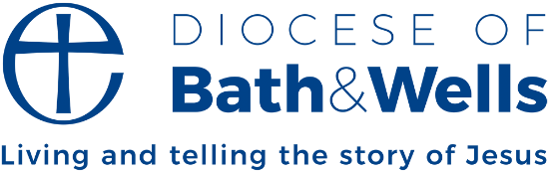

Listening to young people
By Michael Beasley, Bishop of Bath and Wells

Later this month I shall be joining young people from around our diocese on a visit to the Taizé community in France. Taizé offers the opportunity to take a step back from daily life, meet people from around the world, join in a week of prayer, worship and Bible teaching, and reflect on our life of faith. In churches we often speak about God. To visit Taizé is to have a big encounter with God.
This will be the third time I have helped lead a Bath and Wells group on this pilgrimage. Some of our young people will be making a return visit, others attending for the first time. I am looking forward to seeing all they gain from the experience and to simply spending time listening to them and all they have to say.
The opportunity to spend an extended time listening to young people is an utter privilege. While more young people are showing an interest in faith, the Church of England is undeniably still dominated by the older generations. Whenever I can, I value immensely the chance to listen to young people – of their hopes and dreams, their fears and perspectives, their insights and understanding. Such listening is essential if young people are to be fully part of the life of our Church. It’s vital if we are to continue to see the shoots of growth that are happening across our diocese and the wider church.
We’re pursuing this challenge of listening to young people in lots of different ways. It doesn’t just happen at Taizé! Our Young Leaders Hub is one arena. Elsewhere we are looking at how young people can play their full part within the life of our diocesan decision-making bodies and in the national church too. I urge you to do the same where you are.
‘Nothing about us without us’ is a challenge that’s sometimes extended when discussing how young people can participate fully wherever they find themselves. What an aim and a prize this would be for us all to pursue.

