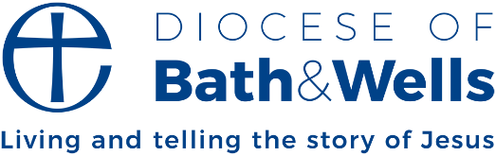

Transforming our communities through the love of Christ
In the early days of the Ukraine war, the Diocese of Hereford, where I was then serving, was approached by Herefordshire Council. They had been so impressed by the work of church members during the pandemic, who stepped up to support their communities in practical ways, that they asked if the diocese could take on organising homes for Ukrainians fleeing the war. Yes, of course, we said. And so began an ongoing partnership, where hundreds of Ukrainian guests have found homes in the Welsh Marches, and hundreds of tonnes of aid has gone across to Ukraine.
That’s just what we do as the church, isn’t it? We see a need in our communities and, motivated by Christ’s love and teaching, we try to meet it. And we do it out of love, not seeking any reward. We are volunteers.
The word ‘volunteer’ comes from words meaning, ‘of a person’s free will.’ Volunteers serve willingly. Freely. Out of love. So many in across our diocese serve our communities willingly, freely, out of love. We are deeply grateful. There are Foodbanks, lunch clubs, debt counselling services, mental health first aiders, bereavement cafes, after-school clubs, and youth drop-ins. That barely scratches the surface. All of this is done in the name of Jesus Christ, the one who came and gave himself for us willingly; freely; out of love. And it’s transformational.
One of the areas of our common diocesan life which I’ll be involved with is our work around Transforming Communities. There will be a lot more to be said in the coming months, but for now, I simply want to thank all our volunteers who serve willingly, freely, and out of love and say how much I’m looking forward to celebrating what we have, and building on it together, transforming our communities through the love of Christ.
Fiona Gibson, Bishop of Taunton

