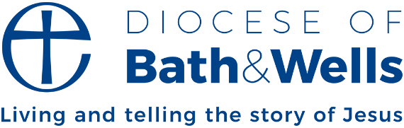

Generations growing in faith together
Our extended family recently got together for a celebration. We were nine adults from 24-68, one toddler, and one dog, and it was glorious! The joy was simply in being together, whatever our age.
I sometimes wonder what would happen in the life of our churches if we could adopt the same outlook there? Each generation glad that the other is there. Each generation contributing something to the whole. Each generation looking to the interests of the others, making sure there was something that spoke to the others even if not to them.
The writer of the Chronicles records something you could miss if you weren’t looking for it. In 2 Chronicles 20, when Judah was facing attack from Ammon and Moab, King Jehoshaphat proclaimed a fast and summoned the people. This is what it says in verse 13:
“All Judah stood before the Lord, with their little ones, their wives, and their children.”
At a time of great peril, when the king was seeking the LORD, all generations came together to pray.
We often think of intergenerational meaning us older ones passing on wisdom to the younger ones, and that’s certainly part of it. But a truly intergenerational family, which the church is, means all generations welcoming one another, valuing one another, learning from one another, and praying with and for one another. It’s not a one-way thing.
Our younger generations are ambassadors from the future, with wisdom to give us about their culture, and how to share the timeless truths of the gospel with their peers. They are leaders and learners, just as we all are.
What might it look like across our diocese if we committed to making room for other generations? What might it look like if, like the people of God in ancient times, we came together in our year of especial focus on prayer - adults, young people, and little ones - and sought the power and wisdom of God together? I have a feeling we’d be surprised!
Fiona Gibson
Who will become Bishop of Taunton on 8 February, 2026

